I B.Tech II Semester Regular Examinations – June, 2024
DISCRETE MATHEMATICAL STRUCTURES

Time: 150 Min (cse/cse(ds)/CSE(ai&ml)) Max. Marks:80M

SECTION – A
Answer all Four questions 4×10M=40M

  - Explain the difference between primitive and compound statements.
  - Show that
    - $\left(P⋁Q\right)⋀\left(¬P⋀\left(¬P∧Q\right)\right) and \left(¬P∧Q\right)$ are logically equivalent
    - $P⟶\left(Q⋁R\right) and (P→Q)⋁(P→R)$ are logically equivalent
  - Show that $((P⋁Q)⋀¬(¬P⋀(¬Q⋁¬R)))⋁(¬P∧¬Q)∨(¬P∧¬R)$ is a tautology.
2
  - Explain POSET and LATTICE with suitable example. Also prove or disprove every POSET is a LATTICE?
  - Without constructing truth table find the principal disjunctive normal form of the statements
- $\left(\sim P→Q\right)∧\left(Q↔Q\right)$.
- $\left(Q∨\left(P∧R\right)\right)∧\sim \left(\left(P∨R\right)∧Q\right).$
  - Prove or disprove a compound proposition which is a contradiction is always a satisfiable.
3
  - Write any two applications of the graph.
  - Explain tree and give two examples of a tree with 6 and 8 vertices respectively. Draw all the spanning trees of the graph G
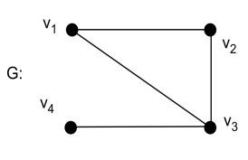
  - Solve the recurrence relation $a_{n}=6 a_{n-1}-9 a_{n-2}$ with initial conditions $a_{0}=1 and a_{1}=4$.

4
  - Find a recurrence relation and initial conditions for the sequence 1, 5, 17, 53, 161, 485…….
  - Suppose that a saleswoman has to visit eight different cities. She must begin her trip in a specified city, but she can visit the other seven cities in any order she wishes. How many possible orders can the saleswoman use when visiting these cities?
  - In how many ways can a set of two positive integers less than 100 be choosen?
.

SECTION - B
Answer all Two questions 2×20M=40M

  - Let be a non-empty set and be the partial order relation of divisibility defined on . Draw Hasse diagram of
  - For the poset [{3, 5, 9, 15, 24, 45}, / ], find
    - The maximal and minimal elements
    - The upper bounds and LUB of {3, 5}
    - The lower bounds and GLB of {15,45}.
  - How many different channels are needed for six stations located at the distances shown in the table, if two stations cannot use the same channel when they are within 150 miles of each other?

 | 1 | 2 | 3 | 4 | 5 | 6
1 | --- | 85 | 175 | 200 | 50 | 100
2 | 85 | --- | 125 | 175 | 100 | 160
3 | 175 | 125 | --- | 100 | 200 | 250
4 | 200 | 175 | 100 | --- | 210 | 220
5 | 50 | 100 | 200 | 210 | --- | 100
6 | 100 | 160 | 250 | 220 | 100 | ---

  - Use K-maps to minimize the Boolean expression
$$xyz + xy\overline{z} + x\overline{y}z + x\overline{y} \overline{z} + \overline{x}yz + \overline{x} \overline{y}z + \overline{x} \overline{y}\overline{z}$$

  - Prove that the graphs shown in the following figure (a) and (b) are isomorphic:
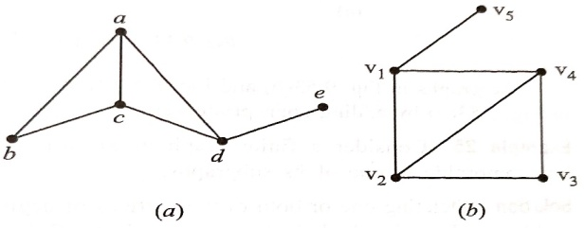
  - Find a minimum spanning tree for the connected weighted graph shown in the following figure using Prim’s Algorithm or Kruskal’s Algorithm?
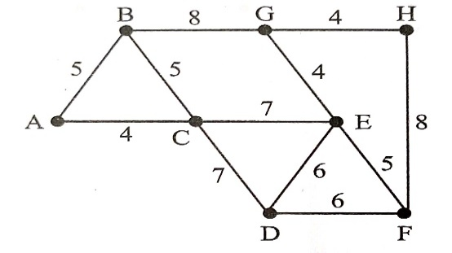

  - Draw the following graphs:
    - A graph which has a Hamiltonian circuit but not an Euler circuit.
    - A graph that has neither an Euler circuit nor a Hamiltonian circuit.

